Supermarket Sales Analysis Report

Introduction
Data analysis plays an important role in understanding business performance and customer behavior. Supermarkets generate a large amount of transactional data every day, which can be analyzed to identify sales patterns, customer preferences, and business opportunities.
This project focuses on analyzing supermarket sales data using Power BI. The main objective is to transform raw transaction data into meaningful visual insights through an interactive dashboard. The analysis helps in understanding sales performance, product demand, customer behavior, branch performance, and payment preferences.

Dataset Description
The dataset contains supermarket transaction records, including invoice information, branch, city, customer type, gender, product line, unit price, quantity, total sales, payment method, cost of goods sold, gross income, and customer ratings. These attributes provide detailed information about customer purchases and overall sales performance.
The dataset was imported into Power BI and prepared for analysis. The data was checked and transformed to ensure that numerical, categorical, and date fields could be used correctly. Measures such as total sales, total quantity, total gross income, number of transactions, and average rating were used to support the analysis.

Data Analysis and Visualization
The Power BI dashboard presents important performance indicators such as total sales, total quantity sold, total gross income, and average customer rating. These indicators provide a quick overview of the supermarket's overall performance.
Product-line analysis is used to compare sales and quantity across different product categories. Branch and city-wise analysis helps identify differences in sales performance between supermarket locations. Customer analysis provides insights into purchasing behavior based on gender and customer type.
The dashboard also includes payment method analysis to understand customer preferences for different payment options. A time-based sales chart is used to observe changes in sales over different dates or months. These visualizations make the raw transaction data easier to understand and allow users to interactively explore the results.

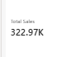
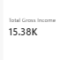

Figure 1: Total Sales Figure 2: Sales by Branch

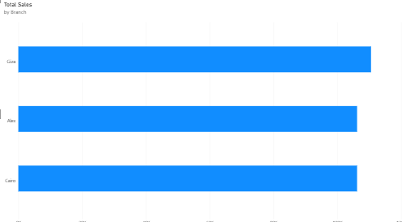
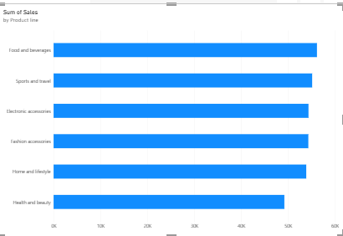
Figure 3: Sales Trend Over Time Figure 4: Sales by Product Line

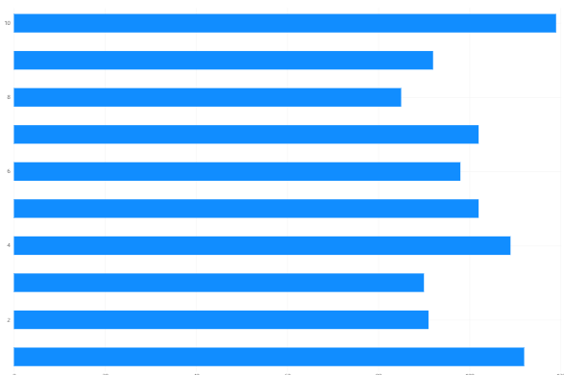
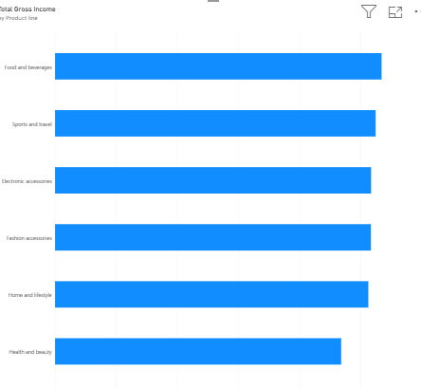
Figure 5: Quantity Sold by Product Line Figure 6: Gross Income by Product

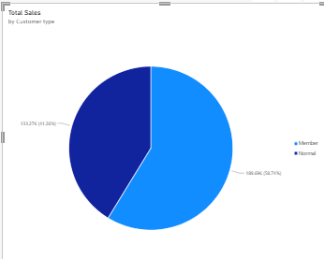
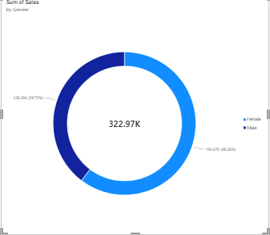
Figure 7: Sales by Gender Figure 8: Sales by Customer Type
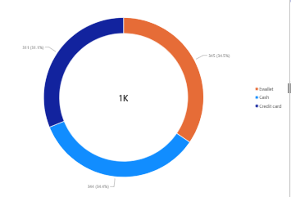
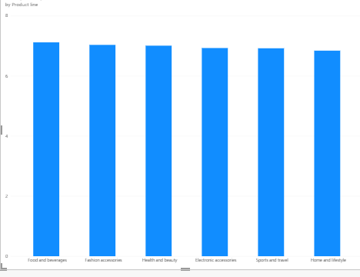
Figure 9: Average Customer Rating by Product Line Figure 10: Payment Method Distribution

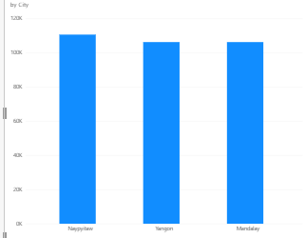
Figure 11: Sales by City
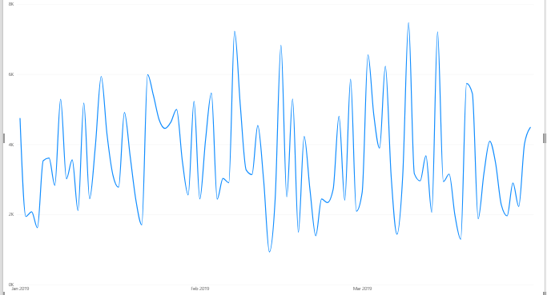

Figure 12: Sales Trend Over Time

Conclusion
The analysis shows that sales performance differs across product lines, branches, and customer groups. Some product categories contribute more to total sales and gross income, while differences can also be observed in customer purchasing behavior.
The analysis of gender and customer type provides useful information about customer segments. Payment method analysis shows the different ways customers complete their purchases, while city and branch analysis provides a better understanding of location-based sales performance. The sales trend also helps identify changes in sales over time.
Overall, the Power BI dashboard provides useful insights into supermarket operations and supports data-driven decision-making. The analysis can help businesses improve inventory planning, understand customer preferences, monitor sales performance, and develop better marketing strategies.
In conclusion, Power BI is an effective business intelligence and data visualization tool for transforming raw supermarket transaction data into meaningful information. The project demonstrates how data warehousing and data mining concepts can be applied to real-world business data to support better decision-making and business growth.

